

**American International University-Bangladesh**

**ADVANCED PROGRAMMING WITH .NET**

**Mid Project Report**

**Section: C**

**Group no - C**

**Group Members**

|  |  |
| --- | --- |
| **Name** | **ID** |
| Sadia Afrin | 20-43666-1 |
| Al Shakib E Elahi | 20-43665-2 |
| Nayeema Hoque | 20-43737-2 |
| Sayeem Bin Ezaz | 20-43770-2 |

**Course Teacher**

**Tanvir Ahmed**

**Database:**

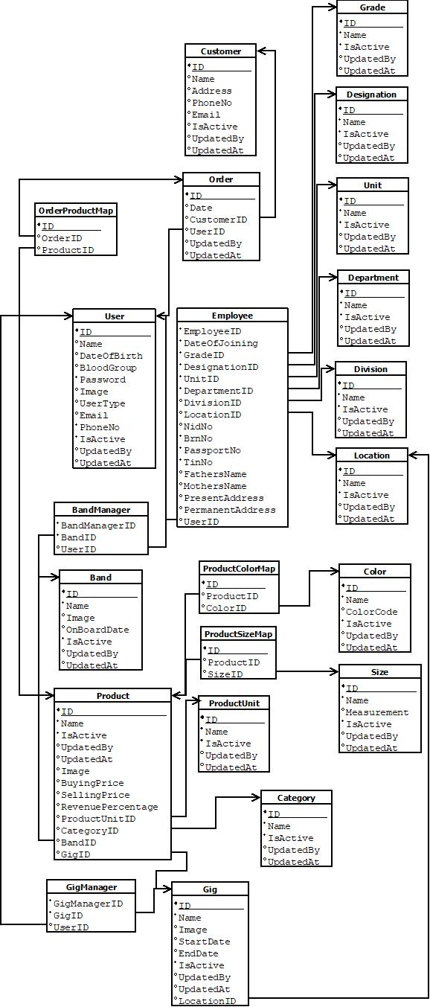

**Figma code:**

**https://www.figma.com/file/c1pFEc55hKPx7NsgKzsacT/G5_C_Spring22-23?node-id=0%3A1&t=u8EmQ6c0r0MosAtV-1**